**STUDENTS PERFORMANEC IN EXAMS**

**METHODOLOGY**

Prediction of academic performance of students is an interesting topic for analysis. This information can help us design an effective mechanism that improve academic results and avoid dropouts in the future. Performances of students creates an opportunity to improve the outcome of their educational objectives. Also, it is remarkable to note that the present project provides answers to the following related research questions:

* What are the major factors influencing the test scores of students in exams?
* How can students’ performance in exams be improved?
* What is the effectiveness of the lunch and test preparation in aiding students’ performance?

**TARGETED POPULATION**

This study was carried out among 1002 students with different characteristics who sat for the same examination but with different personal, social and economic factors.

**HYPOTHESIS:**

The aforementioned attributes that influence student performance such as gender, class attendance, demographic, parental background and economy, test preparation and adequate lunch are categorized into dependent and independent variables. Factors like test preparation and lunch are chosen as dependent variables because they directly affect students’ performance while parents’ background, sex, ethnicity and economy are categorized as independent variables because they have no effects on students’ performance in exams.

**RESEARCH METHOD:**

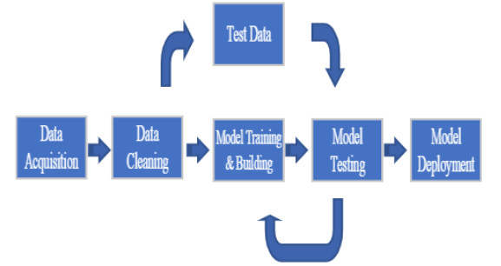We approach the obtained data by using quantitative simulation research methods which will be conducted as demonstrated by the schematic diagram in Fig. 1. The collected data are made to pass through visualization and clustering procedures. In between, and before the classification models’ evaluation phase, the datasets will pass through a pre-processing (e.g. cleansing) stage to make it ready for the analysis phase. Based on the nature of the dataset being analyzed (independent variables and dependent variables), the suitable statistical tools used in this study is regression analysis. The statistical tools used for the data analysis are correlation and linear regression analysis. Specifically, regression analysis is engaged because the dependent variables are considered to be continuous.

**Fig. 1:** Methodological Framework